Curriculum vitae

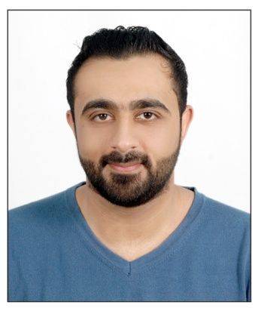

**Name: Hussain Abbas Saeed Nussaif**

**ID Number : 901006840**

**Birth Date: 5th October 1990**

**Address : isa town**

**Phone : 33488558 – 33453141**

**E-mail:** [**h101010@hotmail.com**](mailto:h101010@hotmail.com)

**Nationality : Bahraini**

**Educational Qualifications:**

* **June 2012 till Dec. 2012**

**Certificate in warehouse storage management from Bahrain International Retail Development center**

* **September 2005 till June 2008**

**Secondary high School Certificate from Shaikh Abdulla Bin Isa AL Khalifa.**

**Work Experience :**

* **hashtag restaurant**

**supervisor**

* **Honda**

**after sales admin**

* **Fourseasons hotel**

**security**

* **Viva**

**call center**

* **Home electronics**

**sales**

* **Ebrahim khalil kanoo**

**sales**

**Languages:**

* Arabic and English.

**Skills:**

* Computer skills.
* Hard Worker.
* Able to work under pressure and work in a team.
* Dealing with different nationalities.
* Decision making.
* Creating a nice work environment